

name : Alveena naz
registration number: FA25-BSE-010
PF Lab assignment 1

Question 1;
import java.util.Scanner;
public class FirstJava
{
public static void main(String[] args)
{
Scanner input = new Scanner (System.in);
System.out.println(" Enter the value of pay rate for an hour:");
double payRate = input.nextDouble();
System.out.println(" Enter the numbers of hours you worked : ");
double hoursWorked = input.nextDouble();
double grossIncome = payRate * hoursWorked;
double tax = grossIncome * 0.14;
double netIncome = grossIncome - tax;
double clothes = Math.round(netIncome * 0.10);
double supplies = Math.round( netIncome * 0.01);
double remaining = netIncome - (clothes + supplies);
double savingBonds = remaining * 0.25;
double parentsContribution = savingBonds * 0.50;
System.out.println("income before taxes = $" + grossIncome + "\nincome after taxes = " + netIncome + "\nmoney spend on clothes = $" + clothes + " \nmoney spend on school supplies = $" + supplies + "\nmoney spend to buy saving bonds = $" + savingBonds + "\nmoney spend by parents for additional saving bonds = $" + parentsContribution);
}

}

OUTPUT:
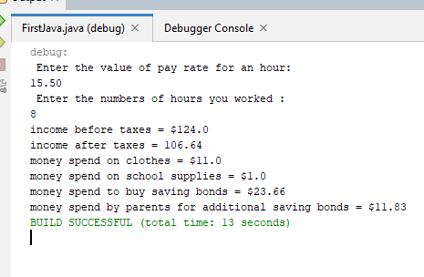

Question 2 :
import java.util.Scanner;
public class FirstJava
{
public static void main(String[] args)
{
Scanner input = new Scanner (System.in);
System.out.println(" Enter any number between 0 and 1000 :");

int number = input.nextInt();
int digit1 = number % 10;
int digit2 = (number / 10) % 10;
int digit3 = (number / 100) % 10;
int digit4 = (number / 1000)% 10;
int sum = digit1 + digit2 + digit3 + digit4;
System.out.println(" Sum of digits are : " + sum);
}
}

Output:
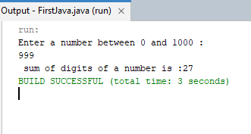

Question 3:

import java.util.Scanner;
public class FirstJava
{
public static void main(String[] args)
{
int degrees = 30;
double radians = Math.toRadians(degrees);
double sin = Math.sin(radians);
double cos = Math.cos(radians);
double tan = Math.tan(radians);
System.out.printf(" Radian = %.3f Sine = %.3f Cosine = %.3f Tangent = %.3f\n " , radians , sin , cos , tan);

degrees = 60;
radians = Math.toRadians(degrees);
sin = Math.sin(radians);
cos = Math.cos(radians);
tan = Math.tan(radians);
System.out.printf("Radian = %.3f Sine = %.3f Cosine = %.3f Tangent = %.3f\n " , radians , sin , cos , tan);

}

}

Output:

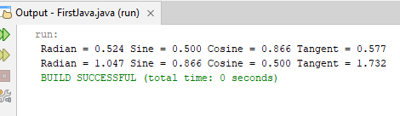

Question 4:
public class FirstJava
{
public static void main(String[] args)
{
boolean b1=true;
boolean b2=false;
boolean b3=(b1==b2);
System.out.println(" The value of b3 is " + b3);

}

}

Output:
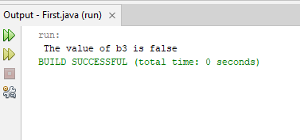

Question 5:
import java.util.Scanner;
public class FirstJava
{
public static void main(String[] args)
{
Scanner input = new Scanner( System.in);
System.out.println(" Guess a toss by choosing 0 for head and 1 for tail: ");
int guess = input.nextInt();
int coinFlip = (int)(Math.random() * 2);

if(guess == coinFlip)
System.out.println(" Your guess is correct");
else
System.out.println(" sorry, your guess is incorrect");

}
}

Output:
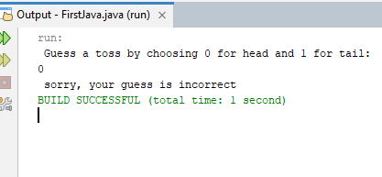

Question 6:
import java.util.Scanner;
public class FirstJava
{
public static void main(String[] args)
{
Scanner input = new Scanner( System.in);
System.out.println(" Enter a month, day and two digit year in numeric form :");
int month = input.nextInt();
int day = input.nextInt();
int year = input.nextInt();

int monthTimeDay = month * day;
if( monthTimeDay == year)
System.out.println(" The date is magic");
else
System.out.println(" The date is not a magic");

}
}

Output:

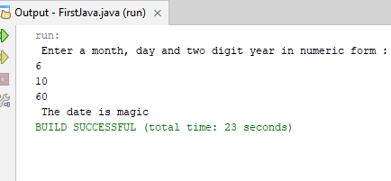

Question 7:
import java.util.Scanner;
public class FirstJava
{
public static void main(String[] args)
{
Scanner input = new Scanner( System.in);
System.out.println("Enter the number of books that you purchased:");
int books = input.nextInt();
switch( books)
{
case 0: System.out.println("You earns 0 points ");
break;
case 1: System.out.println("You earns 5 points ");
break;
case 2: System.out.println("You earns 15 points ");
break;
case 3: System.out.println("You earns 30 points ");
break;
case 4: System.out.println("You earns 60 points ");

}
}
}

Output:

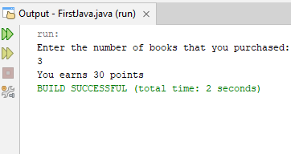

Question 8:
import java.util.Scanner;
public class FirstJava
{
public static void main(String[] argd)
{
Scanner input = new Scanner(System.in);
System.out.println(" Enter a single character:");
String letter = input.next();
char character = letter.charAt(0);

switch(character)
{
case 'a':
case 'e':
case 'i':
case 'o':
case 'u': System.out.println(" The character is " + character + " vowel.");
break;
default: System.out.println(" The character is " + character + " consonant.");

}
}
}

Output:
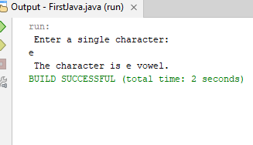

Question 9:
import java.util.Scanner;
public class FirstJava
{
public static void main(String[] args)
{
Scanner input = new Scanner( System.in);
System.out.println(" Enter two numbers ");
int a = input.nextInt();
int b = input.nextInt();
System.out.println(" Select a number for operator : 1: + 2: - 3: * 4: / ");
int opt = input.nextInt();
switch(opt)
{
case 1: System.out.println(" a + b = " + a + b);
break;
case 2: System.out.println(" a - b = " + (a - b));
break;
case 3: System.out.println(" a * b = " + (a * b));
break;
case 4: System.out.println("a / b = " + (a / b));
break;
default: System.out.println(" Invalid number ");
}
}
}

Output:

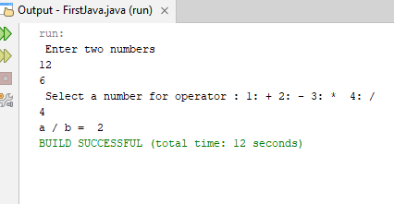

Question 10:
import java.util.Scanner;
public class FirstJava
{
public static void main(String[] args)
{
Scanner input = new Scanner( System.in);
System.out.println(" Enter your salary ");
int salary = input.nextInt();

if( salary >= 30000)
{
double netSalary = salary * 0.08;
double remaining = salary - netSalary;
System.out.println(" Your salary is " + remaining);
}
else if( salary >= 15000 && salary < 30000)
{
double netSalary = salary - 1000;
System.out.println(" Your salary is " + netSalary);
}
else
{
System.out.println(" Your salary is " + salary);
}
}
}

Output:
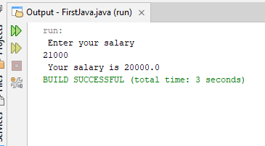

Question 11:
import java.util.Scanner;
public class FirstJava
{
public static void main(String[] args)
{
Scanner input = new Scanner( System.in);
System.out.println(" Enter the number of units ");
int unit = input.nextInt();
int cost;

if( unit <= 400)
{
cost = unit * 3;
System.out.println(" The electricity bill = " + (cost + 200));
}
else if( unit >400 && unit<=600)
{
cost = unit * 5;
System.out.println(" The electricity bill = " + (cost + 200));
}
else if( unit > 600)
{
cost = unit * 8;
System.out.println(" The electricity bill = " + (cost + 200));
}
}

Output:
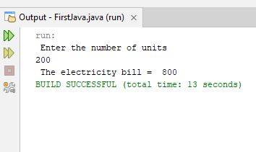

Question 12:
import java.util.Scanner;
public class FirstJava
{
public static void main(String[] args)
{
Scanner input = new Scanner( System.in);
System.out.println(" Enter temperature ");
double temp = input.nextInt();

if( temp > 35)
System.out.println(" Hot Day");
else if( temp>= 25 && temp < 35)
System.out.println(" Pleasant Day");
else if( temp >= 18 && temp <=24)
System.out.println(" Cool Day");
else if(temp < 18)
System.out.println(" Cold Day");
}
}

Output:
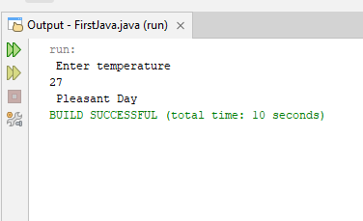

Question 13:

import java.util.Scanner;
public class Main
{
public static void main(String[] args)
{
Scanner input = new Scanner (System.in);
System.out.println(" Enter a number:");
int number = input.nextInt();
if(number%4==0)
System.out.println("number is divisible by 4 ");
else
System.out.println(" number is not divisible by 4 ");
}
}
// 2nd method
String result = (number%4==0) ? “Number is divisible by 4” : “number is not divisible by 4”;
Sustem.out.println(result);

Output:
